1115 SUD Health IT Plan – DY5 (Q4) Update

The state provides the following updates to activities and metrics appearing in the approved HIT Plan. Updates are included in Attachments A1 and A2 included with the report’s submission. Data and updates to process measures following submission of this report will be communicated to CMS during future monthly phone calls and quarterly reports.

- Pg 2 - The state should provide CMS with an analysis of the current status of its health IT infrastructure/”ecosystem” to assess its readiness to support PDMP interoperability. Once completed, the analysis will serve as the basis for the health IT functionalities to be addressed over the course of the demonstration – or the assurance described above.
Currently, LDH is no longer pursuing PDMP Interoperability through the SUPPORT Act Funding. This initiative has been placed on hold.

- Pg 3 – Process measure: Status of contracting as reported by Board of Pharmacy.
The Board of Pharmacy reported that they awarded a new five-year contract in January 2019 to Appriss Health.

- Pg 4 – Process measure: Convene stakeholder group quarterly to develop connectivity plan around PMP into HIE or EHR. Attach minutes.
Currently, there is no update for this process. The initiative has been placed on hold

- Pg 5 – Process measure: Regular updates at quarterly Board of Pharmacy meetings. Attach minutes.
Currently, there is no update for this process. LDH has placed pursuing a PDMP on hold, no quarterly meetings are being held with the Board of Pharmacy on this topic.

- Pg 5 – Process measure: Continue ad hoc meetings with CMS and ONC for IAPD guidance to enhance PMP connectivity in either HIE or EHR.
HIE Integration activities have been placed on hold until further notice.

- Pg 5 – Process measure: Presented to PMP Advisory Council on 1/10/18. Represent a plan proposal to Advisory Council or Board of Pharmacy as follow-up to garner stakeholder support in prep for 2019 session.
All plans for PDMP initiatives have been placed on hold. Legislation is not being pursued at this time.

- Pg 6 – Process measure: During procurement of data warehousing module under modernization, set capability for data match.
The Decision Support System module (previously known as Data Warehouse) is starting procurement activities in 2021, with planned
contract execution by July 2023, if State funding is approved and a vendor is selected timely.

The state intends to execute a contract for its Claims & Encounter module in early 2023. Louisiana will be among
the first states to file a participating addendum for a Medicaid Enterprise System offering. Participating in NASPO for the procurement
will give Louisiana access to a highly configurable, web-based, and automated solution for the Claim and Encounters module in a shorter
time period and for less of a financial investment than a "from scratch" solution.

- Pg. 6 – Process measure: During procurement of pharmacy module, create reporting relationship and data feed into warehousing module.
No update at this time.

- Pg 8 – Process measure: Re-procure managed care contracts on timeline.
LDH published a new RFP for the contracting of managed care organizations on June 23, 2021. The Department announced its intent to
award to five MCOs on 2/11/22.

On June 9, 2022 LDH intends to award managed care organization (MCO) contracts to the following:

AmeriHealth Caritas Louisiana; Healthy Blue; Humana; Louisiana Healthcare Connections; UnitedHealthcare Community Plan Louisiana

The intended contract awards are the result of the Request for Proposals (RFP) for MCOs released on June 24, 2021. Contract awards are not final until the completion of the 14-day protest period and the resolution of any protests. The 14-day period begins on June 9 and ends on June 22.

Pending all necessary approvals, LDH expects new MCO contracts to go live in January 2023.

- Pg 9 – Process measure: Presented to PMP Advisory Council on 1/10/18. Present a plan to Advisory Council or Board of Pharmacy as follow-up to garner stakeholder support in prep for 2019 session.
Legislation is not being pursued at this time.

- Pg 9 – Process measure: If legislation does not proceed, we will pursue alternative data tracking internal to Medicaid.
The state will explore internal data resources needed for tracking as it continues to work towards implementing the Medicaid Data
Warehouse and Pharmacy modules.
The Louisiana Department of Health (LDH) announced its intent to contract with the following Pharmacy Benefit Manager (PBM) after
completing the review of proposals:
Magellan Medicaid Administration, Inc.
The Request for Proposals for a single PBM for the Medicaid managed care program was released on January 14, 2022. Proposals were
due on March 28, 2022. The state announced its intent to contract with Magellan Medicaid Administration, Inc. on August 30, 2022 as the single PBM for Louisiana Medicaid managed care.

- Pg 9/10 – Medicaid data measures
  - Opioid prescription utilization trend (recipients, drug name, amount, payments)
  - Opioid prescription utilization trend in naïve patients (recipients, drug name, amount, payments)

See attachment LA SUDHIT-DY5 (Q4) Report Part A2. This file contains updated data through December 2022.

- Pg. 10 – PMP data measures
  - User statistics by provider type

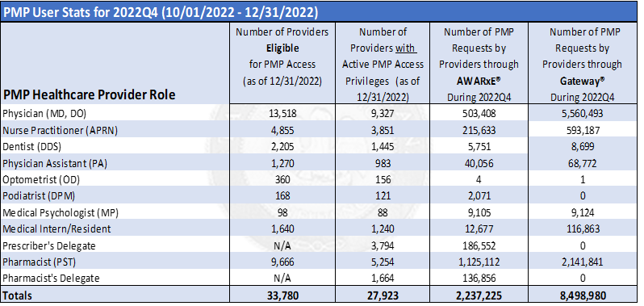

- Eligible transactions reported to PMP

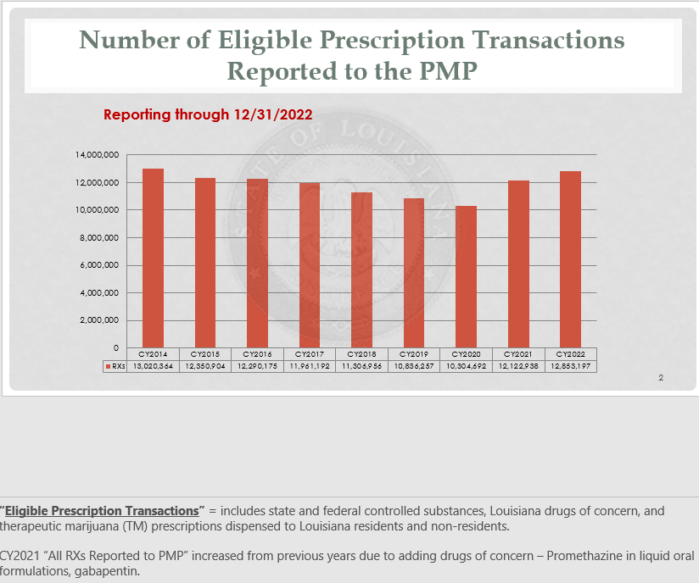

- Prescriber and Pharmacists
No update at this time.

- Pg. 10 – Process measure: Timeline and progress on RFP re-procurement
LDH published a new RFP for the contracting of managed care organizations on June 23,
2021. The Department announced its intent to award to five MCOs on 2/11/22.

On June 9, 2022 LDH intends to award managed care organization (MCO) contracts to the following: AmeriHealth Caritas Louisiana; Healthy Blue; Humana; Louisiana Healthcare Connections; UnitedHealthcare Community Plan

The intended contract awards are the result of the Request for Proposals (RFP) for MCOs
released on June 24, 2021. Contract awards are not final until the completion of the 14-
day protest period and the resolution of any protests. The 14-day period begins on June
9 and ends on June 22. Pending all necessary approvals, LDH expects new MCO
contracts to go live in January 2023.

- Pg 10 – Process measure: Decide which HIE technology will be utilized as an ADT feed.
Currently, ADT feeds are being handled by the Louisiana Emergency Department Information Exchange (LaEDIE) run by the Louisiana Health Care Quality Forum (LHCQF). There are several organizations within the state that are developing their own ADT feed system. This section will be updated when we receive more information. Currently, there are no changes to this information and HIE planned activities have been placed on hold.

- Pg 10 – Process measure: Establish quarterly standing report for MCOs
No updates at this time.

- Pg 10 – Data measure – How many ADT feeds are fed at different locations across the state by MCO and providers
There are 92 hospitals actively providing feeds to LaEDIE. The system provides a daily export to the five Healthy Louisiana MCOs based on their patient lists. The MCOs use this data to provide case management to their recipients.

- Pg 11 - Data measure: Opioid naïve utilization trend monthly report (compare to cancer/palliative care Rx baseline)
Report included in the attached LA SUDHIT-DY5 (Q4) Report Part A2- Excel spreadsheet (Monthly Tracking Impact of 7-day Opioid Quantity Limit and Utilization.xslx).

