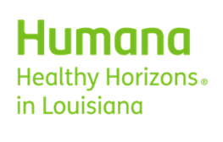

Notification: | HUM 9514
Category: | CPT - Medicine
Topic: | Louisiana Medicaid: pneumococcal vaccine frequency
What is changing? /  Change Description: | We do not reimburse charges for pneumococcal vaccine (PCV/PPSV) CPT codes 90670, 90671, 90677, 90684 or 90732 if the same or similar vaccine code has been billed and paid for the same date of service by any provider.
Why is Humana making this change? / Change Reason: | According to Centers for Disease Control and Prevention (CDC) and Louisiana Medicaid guidance on vaccine immunizations, pneumococcal vaccines should follow an appropriate immunization schedule and should not be administered separately on the same day/encounter.
Language: | English
Impacted Products: | Medicaid- Louisiana

